**Second Hand Cars’ Analysis**

**An Overview of the output of each query**

***Query 1: All car records***

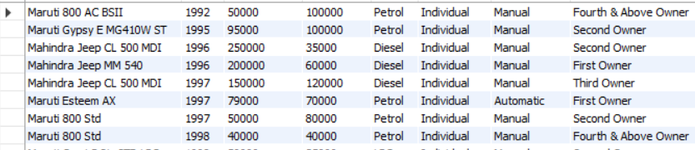

***Query 2: Total no. of cars in the dataset***

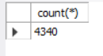

***Query 3: Total number of cars having selling price more than 100000***

**

***Query 4: Name, Odometer Reading & price of the cars having selling price more than 100000***

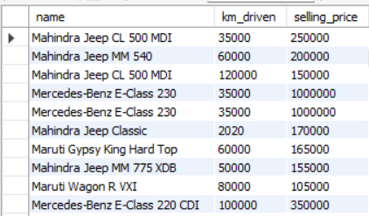

***Query 5: Top 5 costliest cars among all***

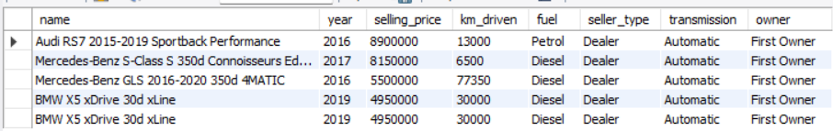

***Query 6: Average selling price***



***Query 7: Minimum Selling Price***



***Query 8: Records of petrol cars identified as first owned and launched after the year 2019***

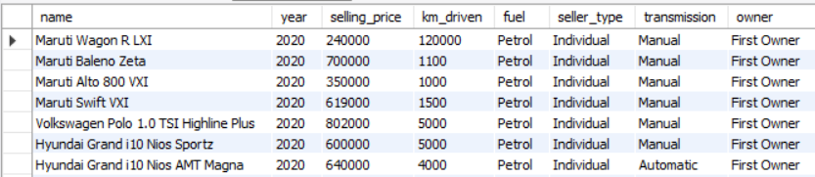

***Query 9: Number of cars categorized on the basis of fuel type and owner***

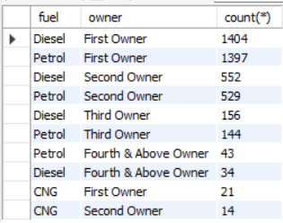

***Query 10: -- Name, price and odometer reading of all automatic cars (sorted in descending order) –***

